|  |  |
| --- | --- |
| Assignment Date | 2 October 2022 |
| Student Name | Prajwel Anandkumar |
| Student Roll Number | 2019504044 |
| Maximum Marks | 2 Marks |

**ASSIGNMENT-3**

LED BLINK: (source code)

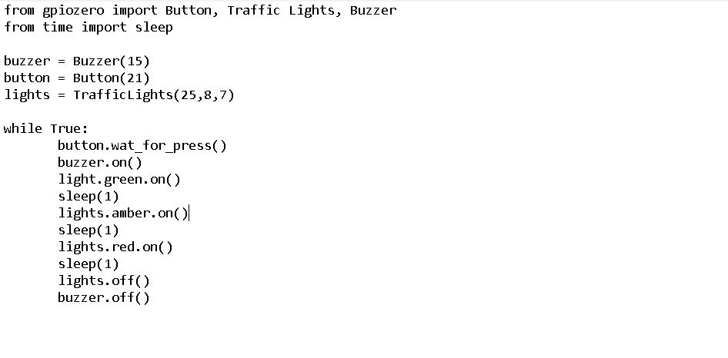

Traffic Light:(source code)

